**Past events:**

Visiting speakers

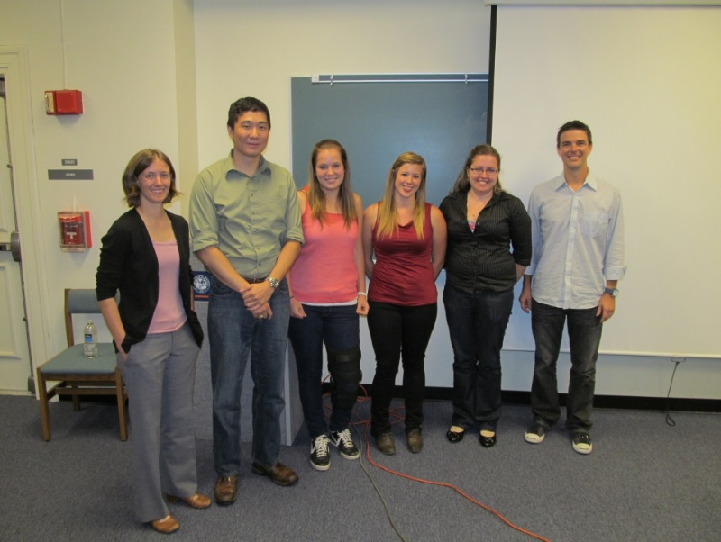In the fall of 2012 we had an academic speaker, Dr. Jennifer Andrew from UF who gave a seminar on her research. We learned about drug delivery and ways to better deliver drugs to the human eye. This was our first POLY/PMSE event and we had a great turnout.

Dr. Fevola Flyer.pdf

In the spring of 2013, we enjoyed the visit of an industrial fellow, Dr. Micheal Fevola, who works at Johnson & Johnson. We learned what is like to work in Polymer Chemistry in industry. He gave a seminar, and we also enjoyed and informal Happy Hour at The Swamp as well as a Q&A breakfast.

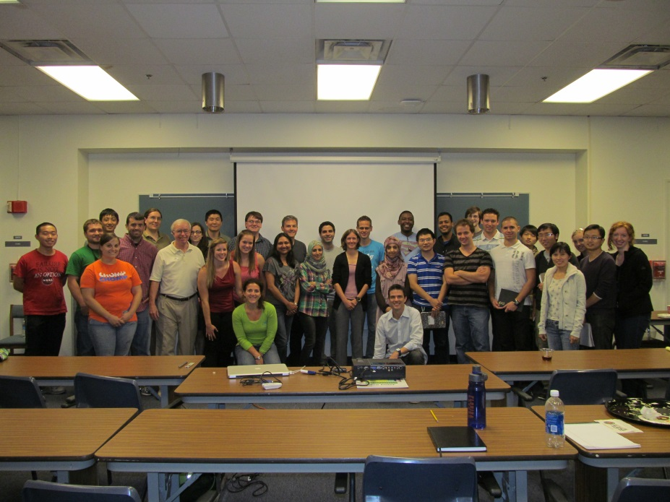

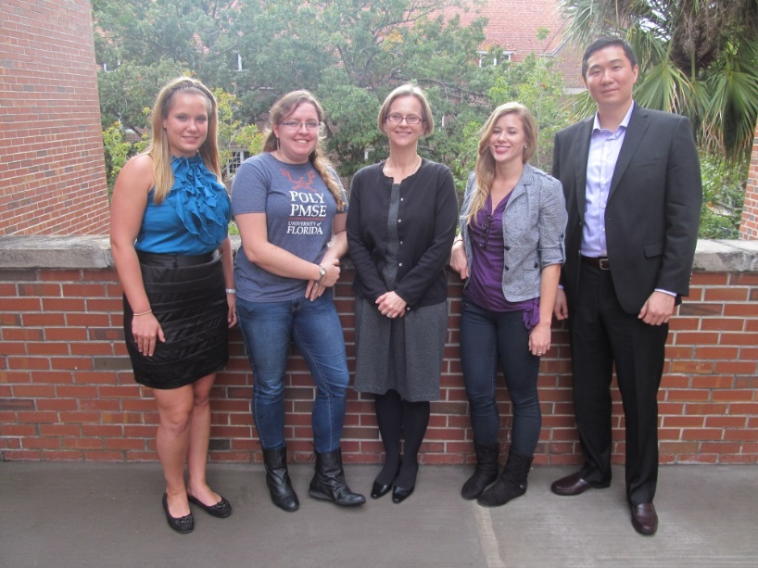

In the fall of 2013, we had the visit of a government lab speaker, Dr. Katherin Beers who works at National Institute of Standards and Technology (NIST) – U.S. Department of Commerce. We enjoyed an informal Happy Hour at The Swamp, and she gave a seminar followed by a Q&A session.

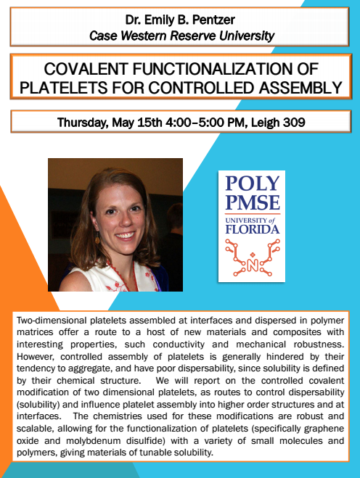In the spring of 2014, Dr. Emily Pentzer visited us from Case Western Reserve University, where she has just been appointed as an assistant professor. She gave a seminar, and we also enjoyed an informal Happy Hour at The Swamp as well as a Q&A breakfast session.

**Other Events:**

POLY/PMSE hosted a speaker from the UF Career Resource Center to give a presentation about how to prepare and improve our resumes and CVs. This is within our interest to help prepare our members for life after graduate school.

In the summer of 2013, we had a very special party to celebrate Dr. Wagener receiving the [Herman F. Mark Polymer Chemistry Award](http://www.polyacs.org/252.html) from the American Chemical Society

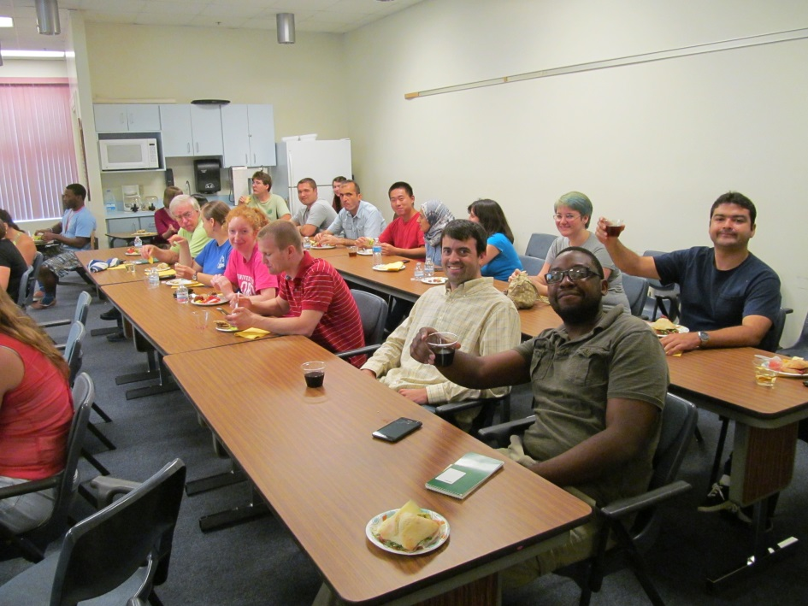

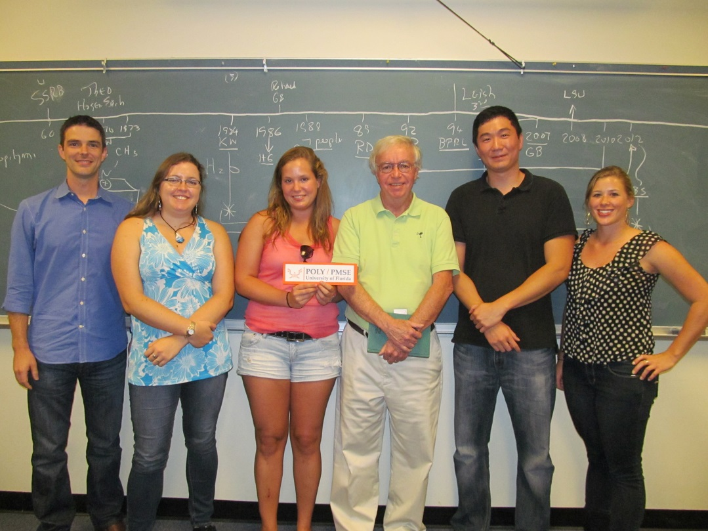

We also get involved in outreach activities. We participated in Chemathon 2013 and 2014 performing polymer experiments for high school students, as well brought experiments to Baby Gator.

